1.AUTHENTICATION
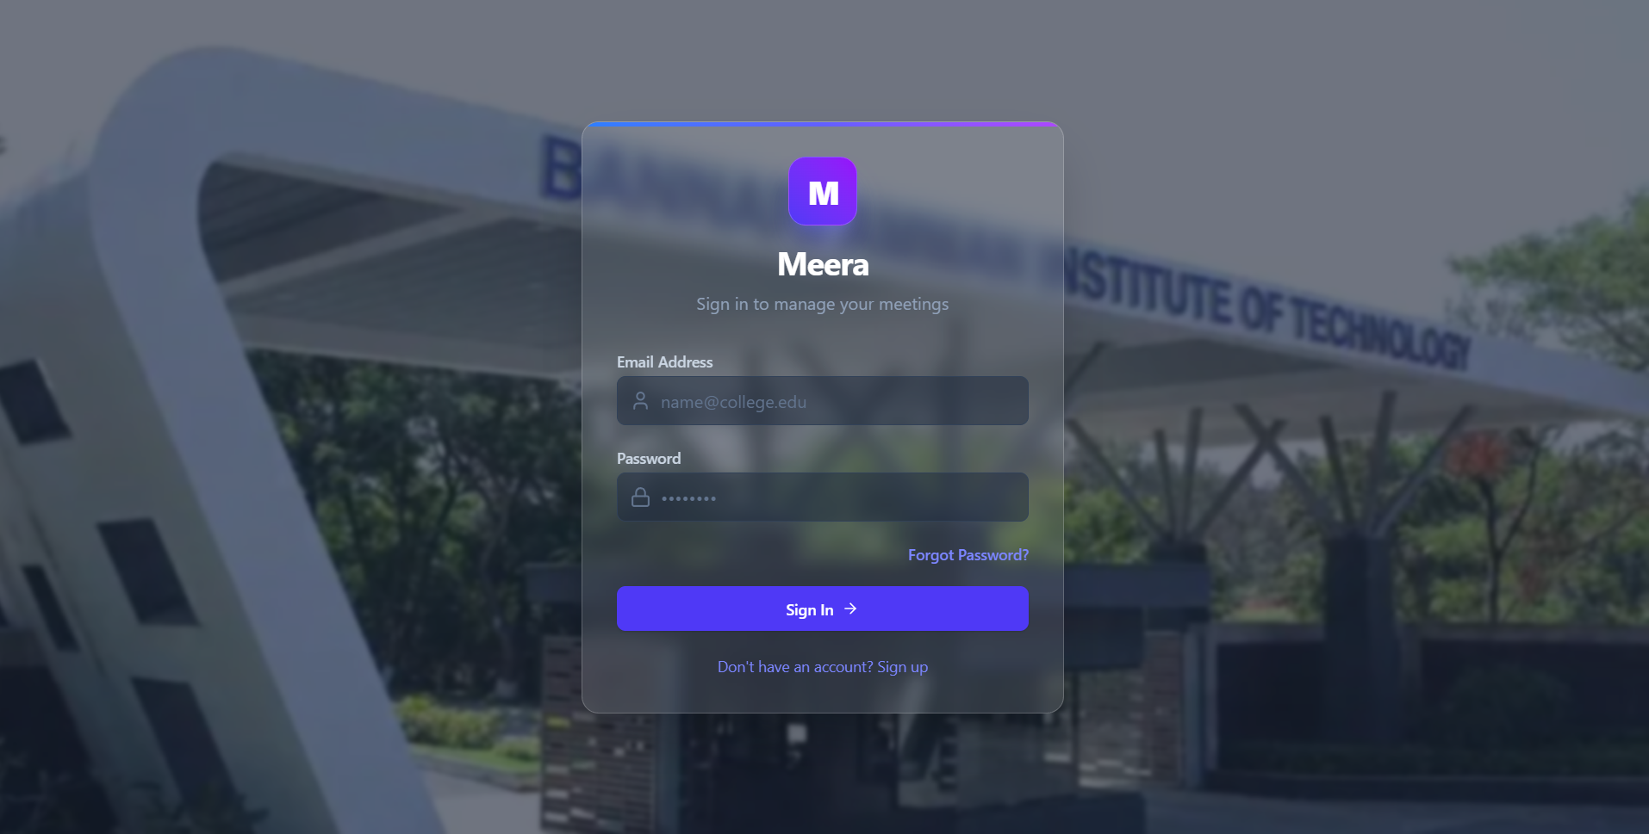

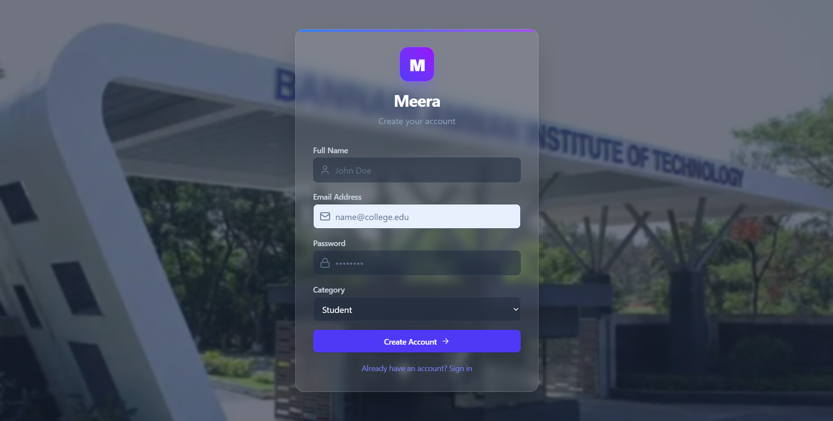

1. Overview & Purpose
The Meera Authentication System (/login & /register) provides a secure, custom database-driven authentication mechanism for the meeting room reservation platform. Designed specifically for university and institutional environments, it enforces role-based access control while offering a modern, visually immersive user experience.
2. Key Features & Design Highlights
Institutional Visual Branding:
Campus Background: Features a high-resolution backdrop of the Bannari Amman Institute of Technology (BIT) main campus entrance gate.
Frosted Glassmorphism UI: Uses semi-transparent glass cards (bg-white/10 with subtle backdrop blur) to maintain high legibility while showcasing the campus background.
Brand Identity: Styled with the signature "M" gradient logo badge and clean modern typography.
Role-Based Public & Admin Access:
Public Self-Registration (/register): Allows Students, Faculty, and Guests to register as Attendees.
Admin-Managed Accounts: High-privilege roles (Organizer & Admin) can only be provisioned by authorized Administrators via the User Management panel.
User Categories:
During registration, users can specify their category (Student, Faculty, or Guest), which is stored directly in their profile for priority booking logic and policy enforcement.

2.DASHBOARD
Admin dashboard

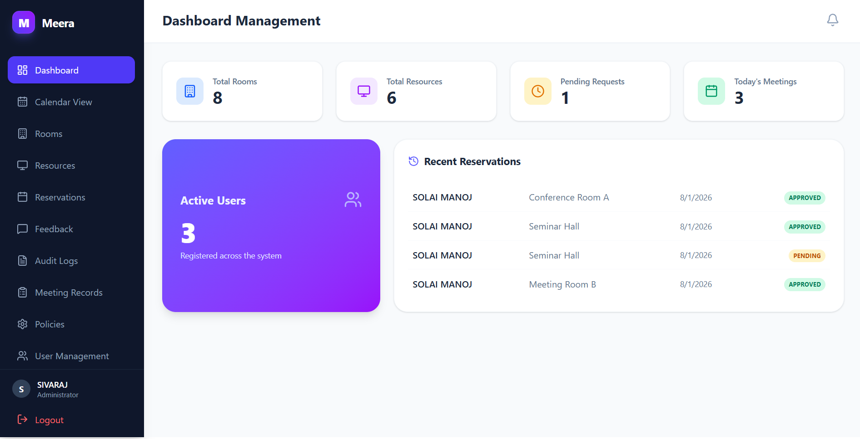

Organizer Dashboard

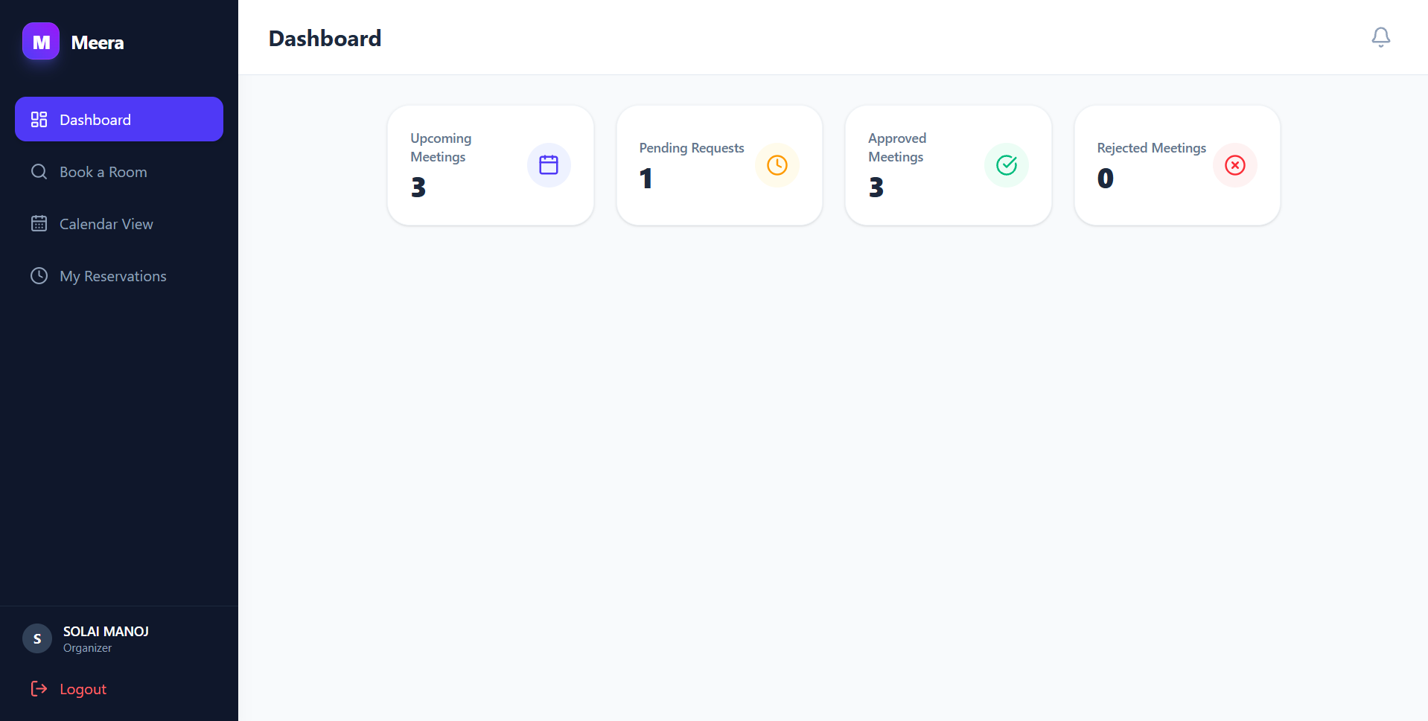

Attendee Dashboard

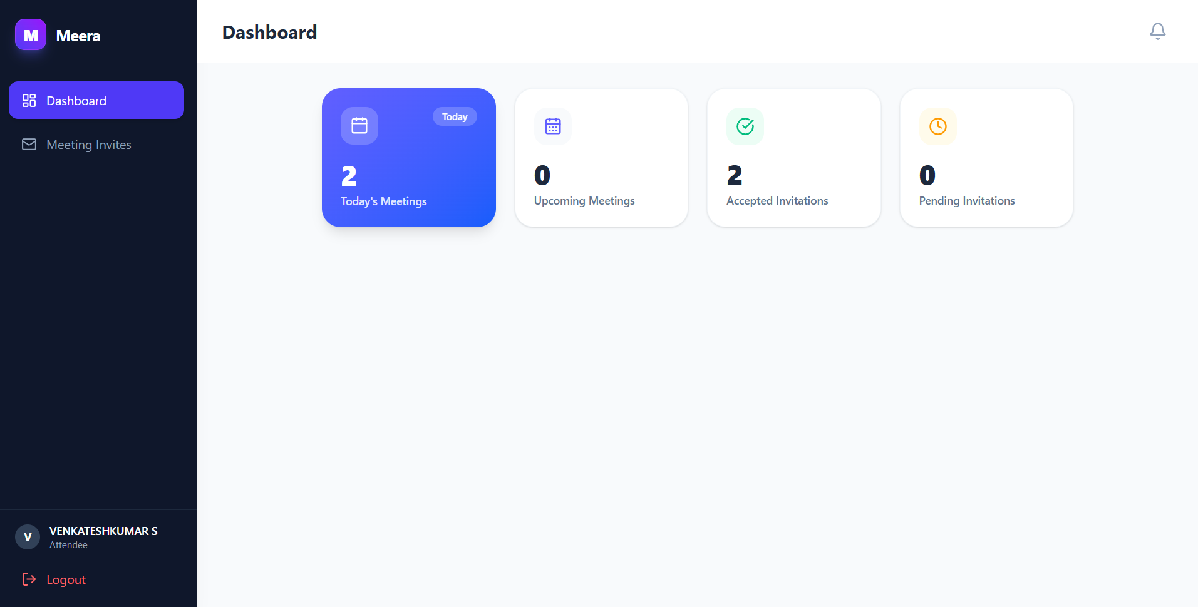

3.RESPONSIVE LAYOUT
Mobile
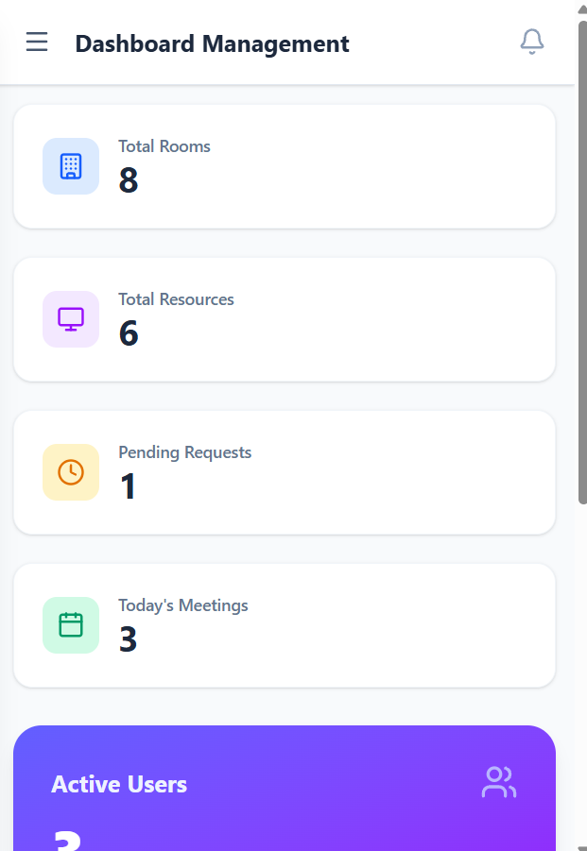

Responsive Navigation & Mobile Drawer:
Added a mobile hamburger menu button (Menu icon) to the header on small screens (< 768px).
Converted the sidebar navigation into a slide-in drawer on mobile devices with a dark backdrop blur overlay (bg-slate-900/60 backdrop-blur-sm).
Clicking any navigation item or clicking outside automatically closes the mobile drawer.
On desktop and tablet screens (≥ 768px), the sidebar remains docked (w-64).
Adaptive Content & Headers:
Added sticky, responsive top headers (px-4 md:px-8 py-4).
Adjusted main content container padding (p-4 md:p-8) and grid layouts for stat cards and room booking options so they adapt seamlessly from 1 column on mobile to multi-column grids on desktop.
Build & Quality Check:
Verified with a clean production build (npm run build completed cleanly in 599ms).

4.NAVIGATION
Navigation flow
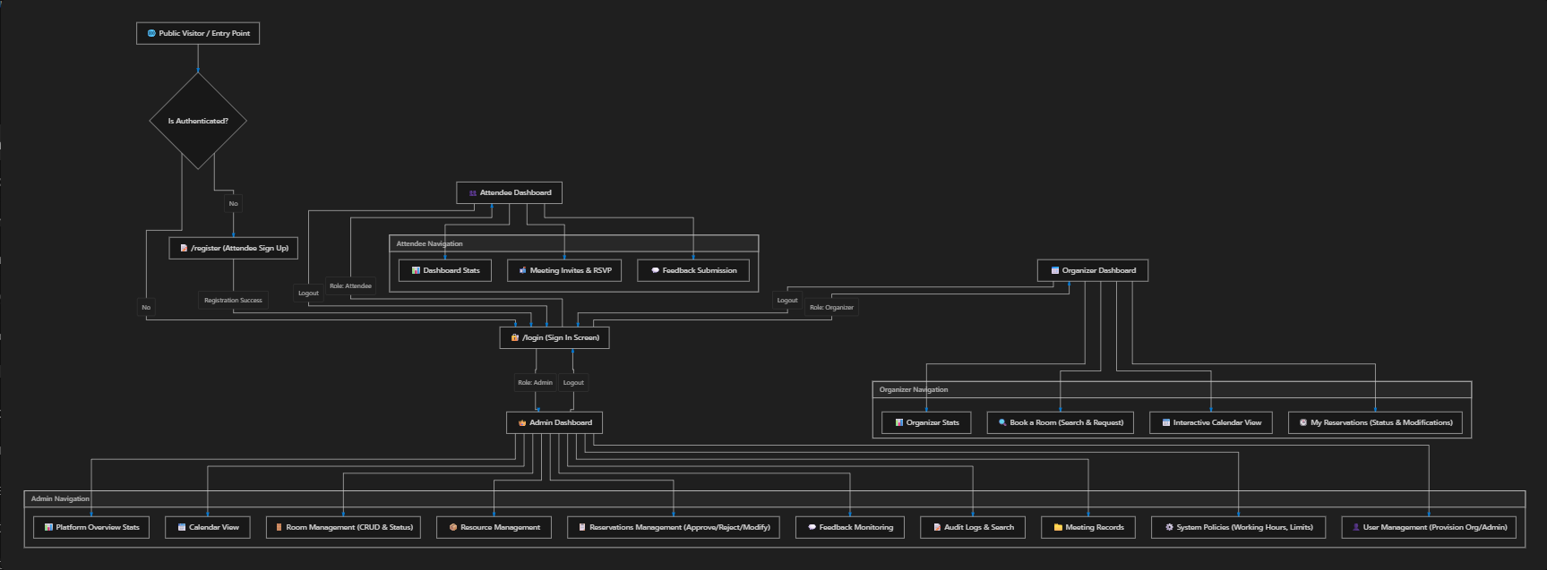
Security & Navigation Controls
JWT Auth Verification: Every protected dashboard route checks for a valid local JWT token (localStorage.getItem('token')) and role verification (user.role). Unauthenticated or invalid role access automatically redirects to /login.
Session Termination (Logout): Clicking Logout on any dashboard clears session tokens from storage, logs a LOGOUT audit event, and returns the user to /login.
Mobile Drawer Navigation: On screen widths < 768px, navigation transforms into a mobile drawer with a backdrop overlay. Selecting any menu item automatically executes the view transition and closes the drawer.

5.FORMS
EXAMPLE:
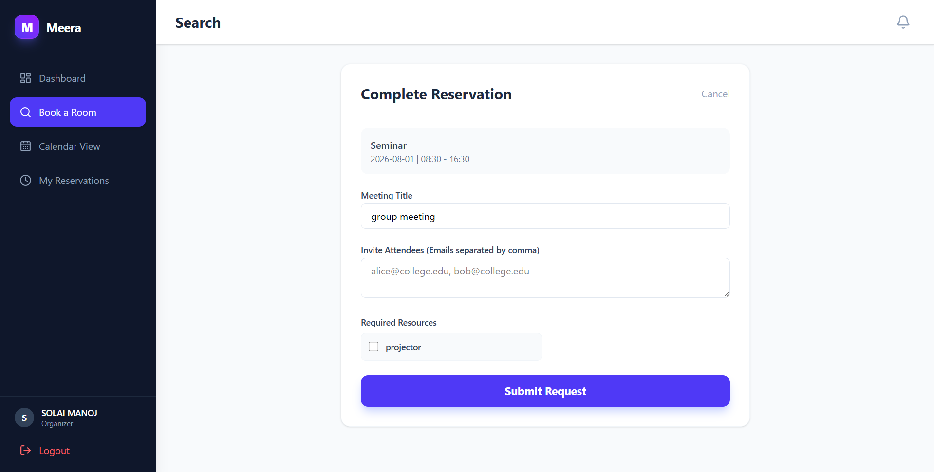

Form | Fields | Purpose
Room Search | Date, Time, Capacity | Find available rooms
Book Room | Meeting Title, Attendees, Resources | Request room booking
Resubmit Booking | Date, Time, Room | Resubmit modified booking

